

Marketing
Report
For Mr P Taylor and Mr J Taylor 15 The Chase, Ropsley

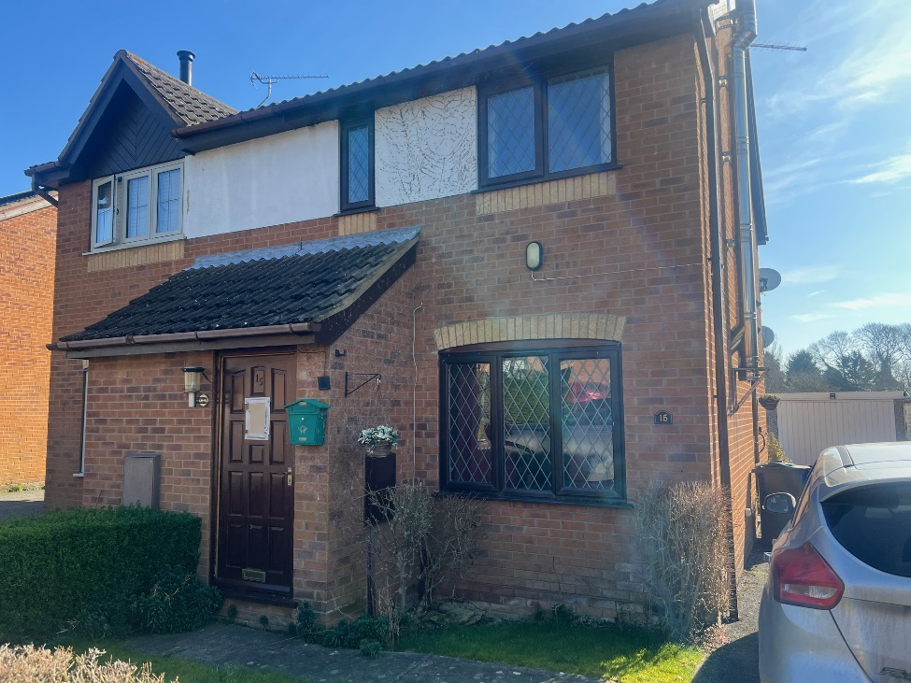
Photograph is used for marketing report only

Report prepared by: Emma Harrison from William H Brown
Date: 6th March 2025
Branch details…
William H Brown, 63 High Street, Grantham, Lincolnshire NG31 6NN
T 01476 566363 E grantham@williamhbrown.co.uk

Market appraisal carried out for…

15 The Chase, Ropsley

Within this report, you will find our recommended asking price for your property, how we will begin the marketing of your home and other ways in which we can help you.

Please feel free to contact me at the office on 01476 566363 at any time.

We’ll get you moving…

Brief description of your home

Lovely semi-detached house
With Kitchen, lounge
Two good sized bedrooms
Bathroom
Lovely Garden with views to the rear
In a very popular village location close to Grantham

Market conditions
We have lots of buyers who are keen to move to your area. In fact, the latest data from Rightmove.co.uk shows, that in the last month there were 126 property searches carried out by people looking for a home like yours. Looking at our own database, we already have 12 buyers registered with us who are looking for a home and where your property closely matches their criteria.

Suggested asking price:
Given the level of interest in properties like yours and the properties which have sold recently in the same area, we would recommend a marketing guide price of £150000 to £160000

Our Fixed Fee at this level would be £2250 plus vat. This is a Fixed Fee, based on a ‘No sale, no fee’ basis, therefore there would be no upfront costs to you until the day of completion. Our Professional marketing would be included within this fee, at no extra cost (Professional photographer, marketing on both Rightmove and Zoopla, social media adverts and Floorplan etc). And with no hidden withdrawal charges.

The only cost to be paid upfront would be for the Energy Performance Certificate which is £79 plus vat.
(If the property does not have a current one)

We also offer In House solicitors who work within our company too, who work on the same ‘No sale, no fee’- their charges for a property at this price would be £899 plus vat, plus any other necessary disbursements.
There would be no hidden charges or withdrawal fees.

You will appreciate that I have carried out a market appraisal, rather than a survey, and in formulating my opinion I have looked at the property as I feel prospective buyers would view it and have taken into consideration other sold similar properties in the area.

Why choose us?

Online extra Pro
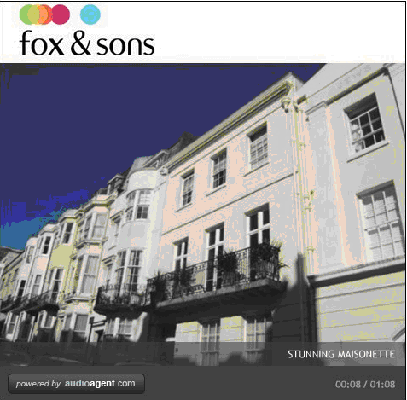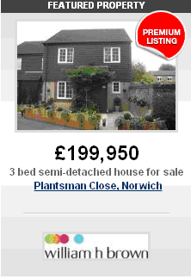

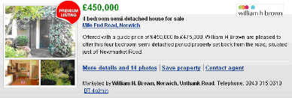
Give your property even greater exposure on the web to really help it stand out from the crowd in 3 distinct ways…

- Audio tour: like an online TV advert for your home combining moving images, music and a professional voiceover. Like to see one? Go to http://tours.audioagent.com/XBB4TD3IUQ

- Featured property on rightmove.co.uk: showcases your property right at the top section of a results page for that all important first week of marketing.

- Premium display on rightmove.co.uk: helps your property stand out with an attention-grabbing, larger display for the duration of your marketing.

- Professional Photography & Enhancement

- Floorplan





Your property in front of millions
Your property will be showcased to millions of potential house hunters through our own national website sequencehome.co.uk as well as leading property portals rightmove.co.uk and zoopla.co.uk amongst others.







Allen & Harris | Bagshaws Residential |
Barnard Marcus | Brown & Merry | Fox & Sons |
Jones & Chapman | Manners & Harrison |
Roger Platt | shipways | swetenhams |
William h brown

Award winning
We are multi-award winning agents, our group has won 34 national awards for our service in the past 7 years.

Our marketing methods work
All of our marketing tools are geared to generate as many potential buyers as possible. Through our proactive branch activities and our web presence, you can be assured we know what works to find you a buyer for your home.

National network
We are part of Sequence, a national network of estate agents with over 290 offices, attracting buyers from right across the country.

My account
Once we are your selling agents, you gain exclusive access to ‘my account’ a specialist feature of our sequencehome.co.uk website.

Here you’ll be able to…

- approve property particulars online
- view web performance reports for your property
- keep in contact with us
- manage your move with digital media and utility switching services

Plus

- gain access to key guides such as successful steps for selling
- see hints and tips for preparing your property to sell
- access handy checklists to inform key people you are moving
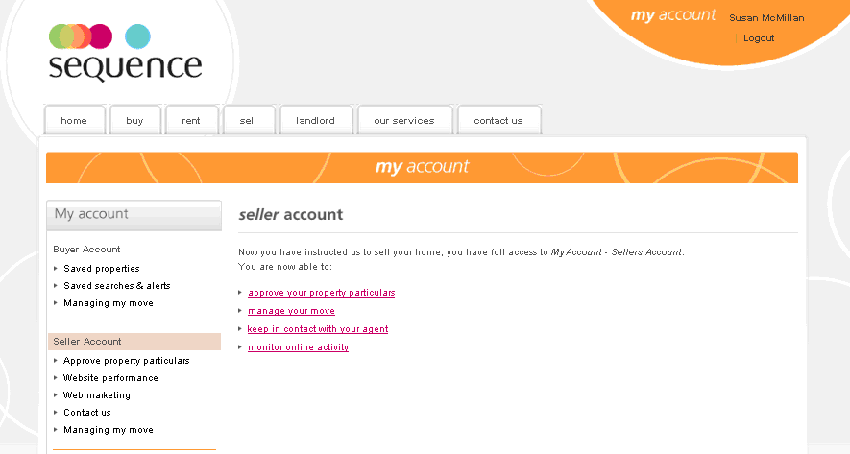

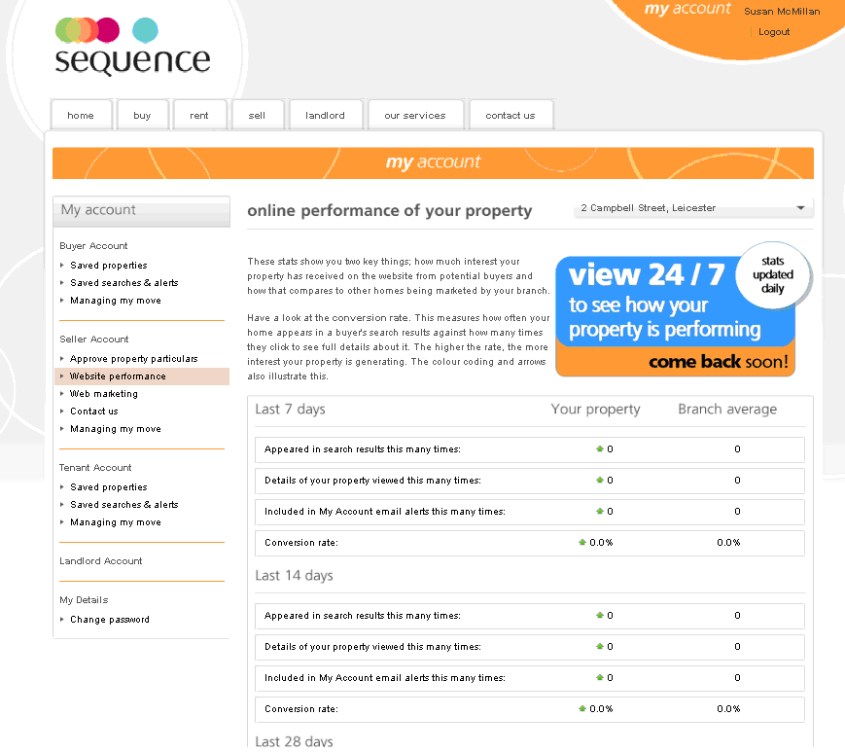

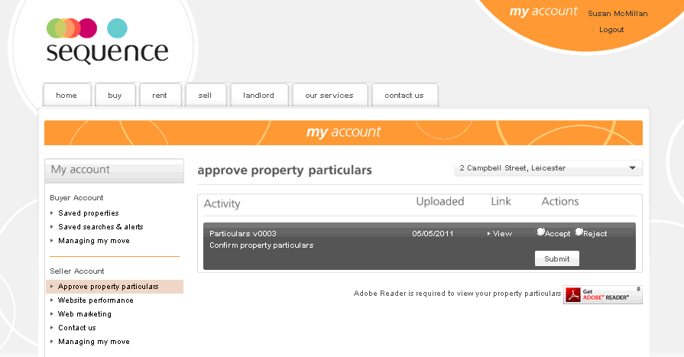

once your property is ready to go on the market…

Here are just some of the things we can do:

- prepare your property particulars
- call buyers registered with us who are interested in a property like yours to arrange viewings
- arrange for your ‘for sale’ board to be put up
- choose the photographs that best promote your property
- add your property to our branch display
- consider options for advertising
- upload details to our own website and other key sites
- circulate details to our offices nearby
- leaflet drop ‘new on the market’ mailers to the surrounding area
- add your home to our property list
- email and post details to prospective purchasers
- speak to viewers and glean feedback
- monitor activity, including the web
- carry out regular marketing reviews
- give you regular updates on progress and activity

Our services…

| Buying and selling | renting and letting |
| Mortgages and insurance products |
| Auctions | land | new homes | conveyancing |
Overseas property | surveys & valuations |

>>
See all our homes on
sequencehome.co.uk

Please note: this is just an indication of our initial marketing approach. We will review the marketing of your property on a regular basis and discuss new ideas with you.

YOUR HOME MAY BE REPOSSESSED IF YOU DO NOT KEEP UP REPAYMENTS ON YOUR MORTGAGE.

Sequence (UK) Limited is an appointed representative of Connells Ltd who is authorised and regulated by the Financial Services Authority for the advising and recommending of mortgages and non-investment products. A broker fee maybe payable.

Trading name of Sequence (UK) Limited, part of the Connells Group.

V1_October 2011

